A Poem about Abraham Lincoln
Mr. Lincoln died in Ford’s Theatre,
While attending a play,
No one could have even guessed,
The events that would unfold that sad day,
It was John Wilkes Booth, an actor,
Who didn’t want President Lincoln alive,
He shot and fatally killed him,
It was April 15th in the year 1865.
Now his face is on the penny,
So if you see one, stop and pick it up,
Put it in your pocket,
Maybe Abe will bring you good luck!
He’s on the five dollar bill too,
So if you really get to thinkin’,
Instead of giving someone a "High Five"
You can give them a "High Lincoln"!

Books about Abraham Lincoln
Abe Lincoln’s Hat
Honest Abe
Abe Lincoln Remembers
Abe Lincoln and Me

Abraham Lincoln Facts and Trivia
Birthday: February 12, 1809
Birthplace: Hardin County, Kentucky
College or University: none
Religion: Presbyterian (never joined any church)
Occupation or Profession: Clerk, Store Owner, Military, Lawyer
Military Rank: Captain
Married: (November 4, 1842) Mary Todd
Children: Robert Todd Lincoln, Edward Baker Lincoln, William Wallace Lincoln, Thomas Lincoln. Three sons predeceased Abraham.
President number: 16
Political Party: Republican
Runner Up: Stephen A. Douglas - George B. McClellan
Vice President: Hannibal Hamlin - Andrew Johnson
Age at Inauguration: 52
Served: 1861-1865
Number of terms : 2
Other Offices or Commissions: House of Representatives (Illinois - 1847-1849), State Legislature (Illinois 1834-1842), Postmaster of New Salem, Illinois
Died: April 15, 1865
Age at Death: 56
Place of Burial: Springfield, Illinois

li

Major Events of the Civil War Period
The following chart maps out key political events, people, and major military actions that preceded and defined the American Civil War, or War Between the States (a term widely used after the war, especially in the Southern states).
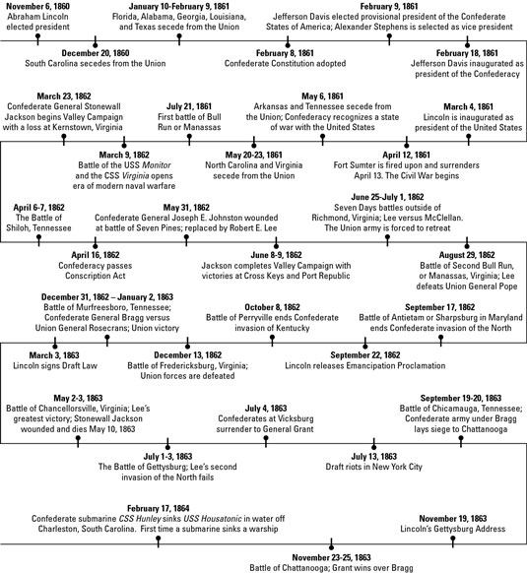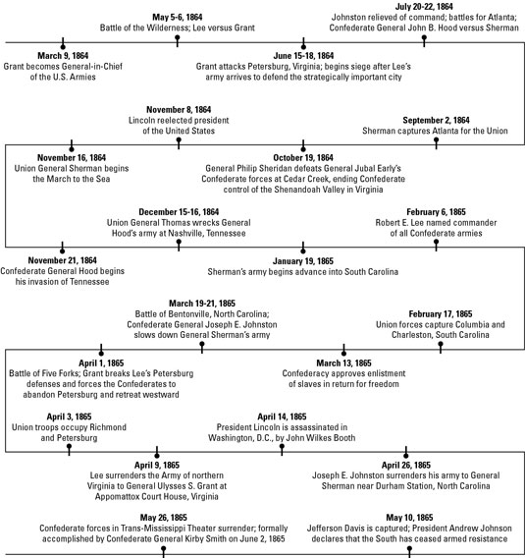
Read more: http://www.dummies.com/how-to/content/the-civil-war-for-dummies-cheat-sheet.html#ixzz1DvVXkWy1

The Battle of Gettysburg was the costliest battle of the American Civil War based on number of casualties. Spanning over three days, from July 1-3, 1863, the Battle resulted in approximately 51,112 individuals being killed, wounded, missing, or captured. Despite the fact that the South continued to fight for two more years, it was a decisive victory for the Union. The South's retreat and terrible losses were a turning point in the war. From that point on, the South had to abandon its attempt to take the war North.

Gettysburg Address
Four score and seven years ago our fathers brought forth, upon this continent, a new nation, conceived in Liberty, and dedicated to the proposition that all men are created equal.
Now we are engaged in a great civil war, testing whether that nation, or any nation so conceived, and so dedicated, can long endure. We are met here on a great battlefield of that war. We have come to dedicate a portion of it as a final resting place for those who here gave their lives that that nation might live. It is altogether fitting and proper that we should do this.
But in a larger sense we can not dedicate - we can not consecrate - we can not hallow this ground. The brave men, living and dead, who struggled, here, have consecrated it far above our poor power to add or detract. The world will little note, nor long remember, what we say here, but can never forget what they did here.
It is for us, the living, rather to be dedicated here to the unfinished work which they have, thus far, so nobly carried on. It is rather for us to be here dedicated to the great task remaining before us - that from these honored dead we take increased devotion to that cause for which they here gave the last full measure of devotion - that we here highly resolve that these dead shall not have died in vain; that this nation shall have a new birth of freedom; and that this government of the people, by the people, for the people, shall not perish from the earth.

Websites for more Information
http://library.thinkquest.org/05aug/00518/abelincoln.htm
http://thebsreport.wordpress.com/2010/02/15/washingtonlincoln-day-abraham-lincoln/
http://www.sonofthesouth.net/slavery/abraham-lincoln/abraham-lincoln-biography.htm
http://americanhistory.about.com/od/civilwarbattles/tp/civil_war_battles.htm
http://gardenofpraise.com/ibdlinco.htm
http://www.2020site.org/fun-facts/Fun-Facts-About-Abraham-Lincoln.html

American Civil War and the Underground Railroad
http://americancivilwar.com/underground_railroad.html

