Native Americans in Texas

Native American groups who lived in Texas can be grouped by Geographical Regions
Gulf Coastal Region – Caddos and Karankwas
The Caddos lived in the Piney woods region of the Coastal Plains
The Karankawas lived in the Southern region of the Gulf Coastal Plains

Caddos
Mound Builders
East Texas - Piney Woods
Caddo Lake - only natural lake in Texas
Confederations- united with other groups to help each other
Hunted Deer and bears for
Fertile land - farmers
Crops – Squash, beans, Maize (corn)
Round Beehive homes surrounded temple
Comfortable lifestyle
Women wore deerskin dresses
Men wore loin cloths
Caddo name means ‘real chiefs’

Write the name of the Native tribe in the correct region
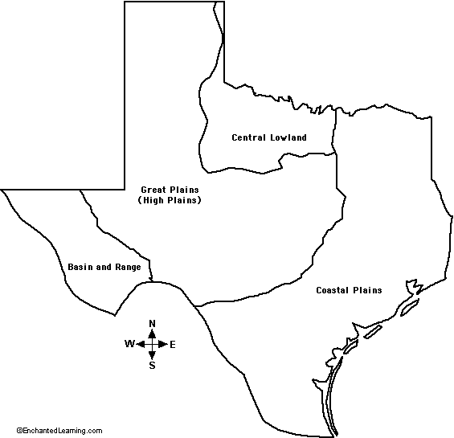

Karankawas
Beaches – Corpus Cristi, Galveston
Used dugouts (canoes)
Fishing on islands off the coast – seafood
Nomads – moved from place to place
Difficulty farming - sandy soil, hot and humid
Cabeza de Vaca ( Spanish explorer) lived among the karankawas and wrote about their lifestyle
Built homes of sticks and straw mats – easy to pick up and move elsewhere

Native Americans in Texas
Native American groups who lived in Texas can be grouped by Geographical Regions. Each tribe adapted to their region and used their natural resources
Great / High Plains and Central Plains – Comanches & Apaches
Mountains and Basins - Jumanos

Comanches and Apache
Lived on the High Plains – Texas Panhandle
Nomadic hunters- Apache & Comanche
Warriors – invaded other tribes
Learned how to ride Mustangs (wild horses)
Buffalo – used for food, clothing and shelter
Women wore fringed dresses – buffalo hide
Men wore breech cloths, moccasins, leggings
Homes – tepees – poles and animal skin
Comanche name means ‘ one who wants to fight me’

Write the name of the Native tribe in the correct region

Jumanos
Mountains and Basin region - dry
West Texas – Rio Grande, El Paso
Also lived in New Mexico & Arizona
Pueblo Civilizations
Made adobe houses- 2 – 3 stories high
Used ladders to enter second floor
Adobe – bricks made of mud and grass
Used irrigation – canals, ditches, pipes to carry water
Some Jumanos were nomads

Study Suggestions
Write journal entries from the point of view of children living in each tribe
Draw and label a map of Texas using a legend to identify the areas where different Native American groups lived
Draw a picture of the different types of homes for each Native American group

Vocabulary Words
Caddos , Karankawas,, Comanche, Apache, Jumanos
Nomads
Confederation
Council
hide
tepees
Irrigation
Adobe
Pueblo
Ancestors
artifacts

