SOCIAL STUDIES PROJECT - 4th Grade
We have been studying Native American groups in Texas. One of the artifacts from the Native Americans of the South West is their beautiful pottery. These vessels were used to hold water, carry food and objects and to serve food. The Pueblo Indians of the southwest, New Mexico and Mexico are well known for their beautifully made pottery
Some styles have very geometric designs, while others include floral patterns or animals
The Southwest Indians use the colors that surround them on their pottery, red of sandstone cliffs, browns and tans of the desert, black and white of polished stones.
The Southwest Indians also decorate their pottery with the designs of nature; the moon, the stars, the sun, horned toads, birds, butterflies, turtles, fish, deer, antelope, mountain lions, bears

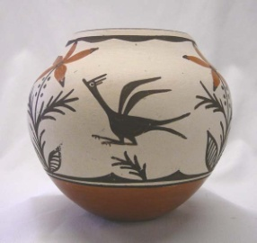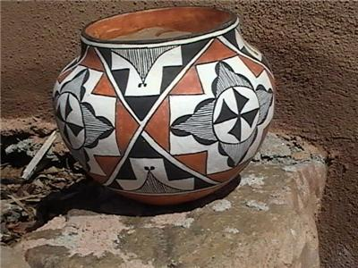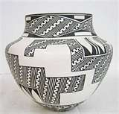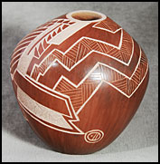

Project Guidelines
) Do some research to inform yourself about different styles of Pueblo pottery: Some Pueblo examples are Zia, Laguna, Santa Clara or San Ildefonso
2) Decide on a theme for your pottery design - Examples: Geometric Shapes Floral Animals Birds
3) First draw a sketch of what you would like your clay pot to look like based on your theme
4) Write a poem using the theme or images of your pottery
5 Make a clay pot using the coil method ( see below for instructions)
6) People all over the world such as Africa, Egypt, China have made pottery from clay . Today we still use pottery bowls and vases for many uses. What will be the purpose of your pottery ?
7) Write a reflection Journal about your experience while doing this project
DUE DATE: Friday November, 19, 2010

Instructions for Making Coil Pot

- Take a piece of clay. Squeeze it in your hands to make a long round coil. Roll the coil on the table, moving your hands up and down the length of the coil to make it thinner.
- Start the pot by making a circle with the coil, wrapping it around itself
- Roll another coil. Attach it where you left off with the first coil. Squeeze the edges of the coil together as you work. When the bottom of the pot is big enough , start raising the walls of the pot by placing the coils on top of each other instead of side by side.
- Continue adding coils. Blend them together on the inside by taking a pencil point or popsicle stick and pressing the clay together where the coils touch.
- Pots can be made into different shapes by placing the coils gradually on top of each other in one direction or another.
- The last step , before drying the pot is to wet the fingertips and rub a small amount of water over the pot to create a smooth surface.
- Dry at least a week. Fire if possible. The pots can survive without firing if you take care of them.

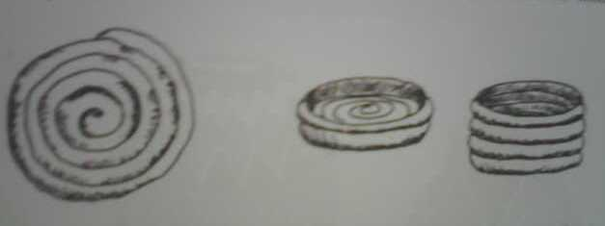

Have fun decorating your clay pot!!

- Look back at your sketch and your chosen theme, colors, patterns
- Try to recreate the sketched design on your clay pot
- One method is to incise or scrape the design into the painted clay with a sharp tool. The clay color will show through the incised line. For example if you paint black paint on the pot and scrape lines into it, the red clay will show through where the paint has been scraped off.
- Use tempera paint to decorate.
- After the paint dries, ask a parent or guardian to spray the finished pot with glossy varnish. The varnish spray must be used outdoors.
MATERIALS: You will need, 2lbs clay, newspaper, pencils, popsicle sticks, opened paper clips, tempera paint, eg. (black, reddish brown, white, turquoise) paper plates, water, sponges, brushes (large/small), pictures of vases for inspiration, and a creative mind.

