Study Guide for Social Studies Quiz on December 16, 2010
Students should take home their social studies folder to help them prepare for the quiz

Where and why did the Spanish establish missions in Texas? ______________________________
____________________________________________________________________________________
Name a famous Mission in San Antonio, Texas ______________________________________________

Why is the Alamo an important part of the history of Texas? ___________________________________
__________________________________________________________________________________________________________________________________________________________________________
Who was Clara Driscoll? _________________________________________________________________
How did she help the State of Texas _______________________________________________________

Write 3 facts about Clara Driscoll’s life______________________________________________________
_____________________________________________________________________________________
_____________________________________________________________________________________
What is Laguna Gloria? __________________________________________________________________

Define these words
Philanthropist ________________________________________________________________________

Biography____________________________________________________________________________

Autobiography ________________________________________________________________________

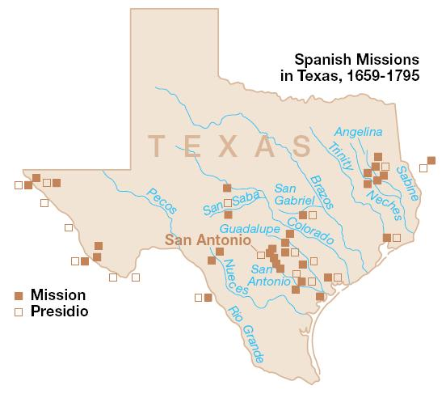

Helpful Links about the biography of Clara Driscoll
http://www.tamu.edu/ccbn/dewitt/adp/history/bios/driscoll/clara.html

http://en.wikipedia.org/wiki/Clara_Driscoll_(philanthropist)

More Info on Missions
http://www.h-net.org/~latam/powerpoints/TheSpanishMissionsofTexas.pdf

